**CALAHEX (Caribbean and Latin America Hybrid Exchange System) Architecture Design**

1. Technical Design

* Hosting
* Live Hosting: GoDaddy hosting - Suite Level

<https://ru.godaddy.com/hosting/web-hosting>

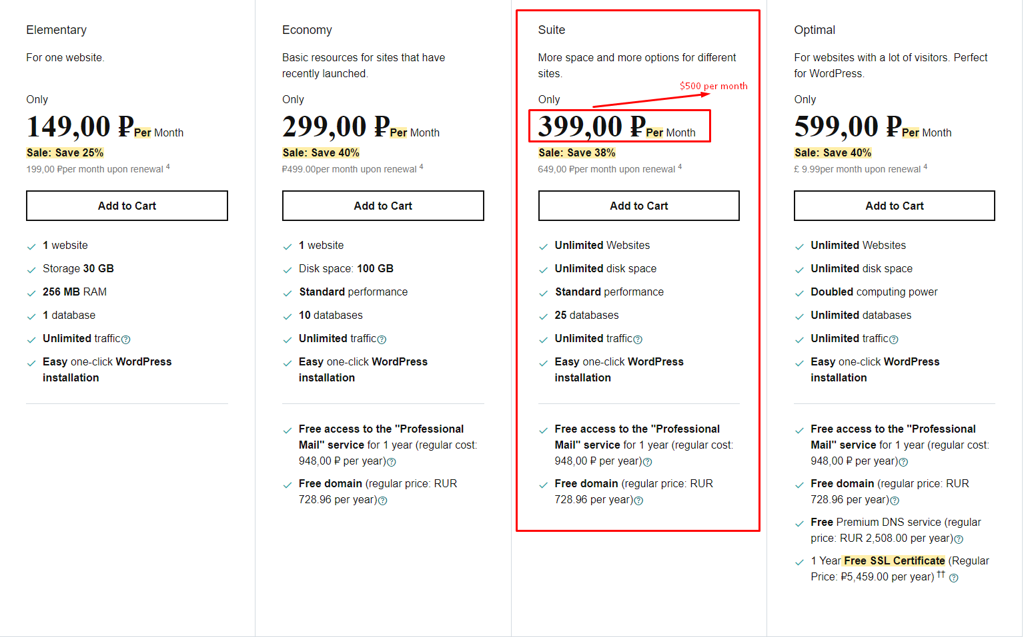

* Dev Hosting: Domain hosting – Full version

<https://www1.domain.com>

* APIs:
* Exchange, Deposit & Withdraw API: Poloniex API

<https://poloniex.com/>

* Trading View API: Tradingview API

<https://www.tradingview.com/>

* Create new token API: Blockcypher API

<https://api.blockcypher.com/>

* Centralized part

Domain: calahex.com

* + Backend

Laravel

* + Frontend

Reactjs

* + Database

MySQL

* + Engine

Blockchain

* Decentralized part

Domain: calahex.org

* Database

Bigchain Database

<https://www.bigchaindb.com/features/>

* Frontend

React.js

* Frontend extension

Web3.js

* Smart Contracts:

Solidity

* Marketing part

Domain: calahex.online

* + Backend

PHP

* + Frontend

Bootstrap theme

1. Page Function Design(Mockup)
   * Centralized Platform

* Spec

Font: Proxima nova

Logo: Calahex

Header: Logo, Crypto Exchange, Token Exchange, Margin Trading, Futures Trading, Buy Crypto, Token Info Base, CAX Rewards, About us, Caladex

Footer: Let’s trade, About Calahex, Futures, Support, Social

* Main pages (logout)
  + Landing

Introduce Calahex centralized platform

Content: Token Listing, Token Exchange. Buy Crypto, New, View Listed Tokens, Futures Trading, Our Community, 24/7 Support, Job Opportunities, Download on Google play, Download on App store

* + Crypto exchange

Exchange between crypto currencies and normal currencies

* + Token exchange

Exchange between ethereum based tokens and crypto currencies

* + Margin trading

Margin Trade

* + Futures trading

Futures Trade including Corn Futures

* + Buy Crypto

Buy BTC/USDT using USD/EUR

* + Token info base

Listing current tokens on the platform with detailed info

* + CAX Rewards

Rewards page for CAX – Special token for Calahex platform

* + About Us

Link to www.kamhol.com

* + Log in

Log in with email and password, Calahex news

* + Sign up

Sign up with email, password or referral code

* Main pages (login)

Crypto exchange, Token exchange, Futures trading

* Wallet pages (login)
  + Account overview

Total balance

Account - Spot, Margin(Cross), Margin(Isolated), Futures(USDT), Futures(COIN), Savings, Pool

* + Spot Account
    - Wallet

Total balance, Cash balance, Crypto balance, Token balance

* + - Deposit

Buy Crypto (Payment method, details, history)

Buy Fiat (Crypto selection, network selection, verification, history)

* + - Withdraw

Sell Crypto (Transfer detail, history)

Sell Fiat (Transfer method, history)

* + Margin Account

Total balance, Crypto balance, Token balance, Margin level

* + Futures Account

Open futures account, Futures referral

* + Savings Account

Saving, Locked staking, Defi staking

* + Pool Account

Total balance, Crypto balance, Token balance

* + Transfer balance

Transfer between spot, margin, futures, savings, pool accounts in the wallet

* + Transaction history

Deposit & Withdraw, Transfer, Distribution

* Settings pages (login)
  + Profile

Info, Limits & Features

* + Referral

Referral code, link, link list, account

* + 2FA

Enable 2FA, 16-digit key

* + Change Password

Change password, Support articles

* Activity pages (login)
  + Wallet

Withdrawals, Deposits, Distributions, Bank Withdrawals, Bank deposits, Referral Rewards, Time filter

* + Open orders

Buys, Sells, Exchange, Margin, Pair filter, Time filter

* + Trades

Buys, Sells, Time filter

* + Futures
    - Trade history

Symbol, Order type, type, Time filter, history

* + - Funding history

Symbol, Time filter, history

* + - Order history

Symbol, Order type, type, Time filter, history

* + - Transaction history

Time filter, history

* + - PNL history

Settlement coin, Time filter, history

* + Decentralized Platform
* Spec

Font: Proxima nova

Logo: Caladex

Header: Logo, Crypto Exchange, Token Exchange, Token Listing, Support, Calahex

Footer: Apply for listing, Q&A, Social

* Main pages (logout)
  + Landing

News, Token Listing

* + Crypto exchange

Exchange between crypto currencies and normal currencies

* + Token exchange

Exchange between ethereum based tokens and crypto currencies

* + Token listing

List a new token with name, logo, id, symbol, decimal, unit, pair type

* + Sign in

Sign in with CALALINK (Wallet Extension for caladex platform)

* Main pages (login)
  + Landing, Crypto exchange, Token exchange, Token listing
  + Balance page (login)

Total value, Balances for tokens of the wallet with receive, send, trade operation

* + Orders pages (login)
    - Current order

Current order list

* Order history

Order history list

* Calalink (Extension)
  + Login

Login with Calalink account info

* + Main
    - List

Account balance list on the wallet based on tokens

* + - Receive

Show account address to receive tokens

* + - Send

Send tokens into others

* + Hardware wallet

Connect ledger with your pc and open CalaApp in Ledger

* + Decentralized App
    - Popular

Show popular DApp based exchange platforms

* + - Recents

Show DApp exchange platform shown history

* + Setup
    - Address book

All the addresses log which is used from owner’s account

* + - Decentralized App white list

DApp white list registered on the owner’s account

* + - Node

Node setting

* + Account
    - Lock account

Lock account until correct password typed

* + - Change account name

Change account name with correct password

* + - Export account

Export account with correct password

* + - Delete account

Delete account with correct password